**All in One Card**

### Prof. Milind Rane, Ruzan Verma, Moksh Sanghvi, Rohitashva Kumawat, Shreya Mantri

**Vishwakarma Institute of Technology, Pune, 411037, Maharashtra, India**

* 1. ABSTRACT

**The All-In-One Card, featuring a TFT OLED display and an ESP32 microcontroller, offers a compact solution for displaying personal identification cards. Its hardware setup, software architecture, and user interaction mechanisms demonstrate its versatility and potential for seamless integration into IoT systems.**

**Keywords: All-In-One Card, TFT OLED Display, ESP32 Microcontroller, User Interface, IoT**

* 1. INTRODUCTION

1. THEORY

The rapid advancements in embedded systems, display technologies, and IoT applications havepaved the way for innovative solutions in compact and portable devices. One such innovation is the integration of a TFT OLED (Thin-Film Transistor Organic Light Emitting Diode) display with an ESP32 microcontroller in an All-In-One Card. This device aims to provide a versatile platform for displaying images of cards like id, aadhar, license etc. The TFT OLED display offers advantages such ashigh contrast, wide viewing angles, and low power consumption, making it an ideal choice for a display component. Coupled with the ESP32 microcontroller, which provides computing power, connectivity options such as Bluetooth and Wi-fi, and an extensive ecosystem of libraries andtools, this integration results in a compact, powerful, and easily programmable device.

In this paper, we present the design and implementation details of the All-In-One Card. We describe the hardware components, software architecture, and user interface implementation through experimental results, showcasing its potential for diverse applications and its seamless integration into IoT systems experience for healthcare providers and patients alike.

Additionally, we demonstrate the device's capabilities.

1. LITERATURE REVIEW

For developing All in One card we referred to these research papers:

1. Single ATM Card for multiple access: The objective of the paper is to propose a system that uses a single card for accessing multiple accounts, such as banking purposes, license, passport, and ID card. The system aims to provide convenience to users by eliminating the need to carry multiple cards and increasing security through the use of biometric authentication. The paper also highlights the advantages of the proposed system, such as low power consumption, reduced time, and easy handling.
2. The Application and Research of Intelligent All-in-One Card in the Smart Campus of

Colleges and Universities: The main objective of this paper is to introduce and discuss the construction goals and content of the smart card system in the university campus, highlighting its practical application and the important role it plays in creating an intelligent campus. The paper focuses on upgrading the existing all-in-one card system, enriching the application of smart campus all-in-one cards, and improving the functions and services provided by the system.

1. Multi Bank Smart Card : The objective of the paper is to propose a system that integrates multiple bank accounts, passport details, and ration and hospital applications into a single smart card. This system aims to reduce the effort of carrying multiple cards and provide easier access to various services for the users.
   1. METHODOLOGY

The methodology for implementing the "All-In-One Card with TFT OLED Display and ESP32 Microcontroller" involves a comprehensive approach encompassing hardware setup, software development, and user interface design. In the hardware setup

phase, appropriate components, including a TFT OLED display, a Push Button and an ESP32 microcontroller, are carefully selected based on technical specifications, compatibility, and power requirements. An physical enclosure is designed to house these components, providing a secure and aesthetically pleasing casing for the All-In-One Card. Moving to software development, firmware code is written in Arduino IDE for the ESP32 microcontroller to control the TFT OLED display (using U8g2 library) using push button. To display an image, we have converted the image into byte arrays[] ([6] image2cpp) for use with (monochrome) displays such as OLEDs on our ESP32. This code connects our system to wi-fi and has logic for displaying several card kinds, such as licenses, debit cards, and ID cards. It also allows users to interact with the system by manually switching between these cards using a push button and remotely via the internet. In order to conveniently control our system remotely using an IP address (192.168.1.104), we have also constructed a wi-fi connection for it using ESP32 microcontroller.

1. Fig. 1 Hardware setup

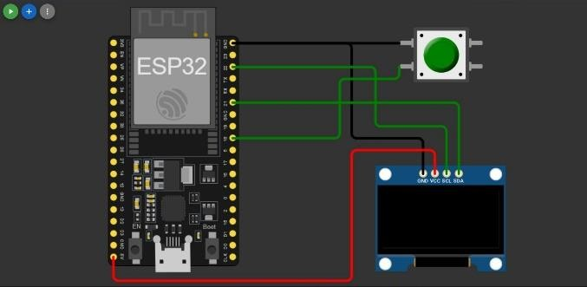

1. RESULTS AND DISCUSSIONS

The All-In-One Card demonstrated effective display capabilities, showcasing visually accurate representations of id cards, debit cards, and licenses on the TFT OLED display. Users could seamlessly navigate through the interface to switch between the various card types. The TFT OLED display presented information clearly, utilizing vibrant colors and high contrast ratios, ensuring optimal readability even in varying lighting conditions. The user interaction with the system was intuitive, enabling users to easily toggle between cards. Real-time data synchronization and updates further enhanced the device's functionality, allowing for dynamic displays and reflecting changes promptly.

The successful implementation of the All-In-One Card, integrating TFT OLED display and ESP32 microcontroller, holds significant potential for diverse applications. In various scenarios, users often carry multiple cards such as credit cards, debit cards, and

licenses. The All-In-One Card consolidates these cards into a single, compact device, offering convenience and reducing the need to carry multiple physical cards. This innovation aligns with the ongoing trend of digitization and minimalism, contributing to a more streamlined and organized user experience. Additionally, our system displays a QR code that has a QR code scanning feature that sends users to a website with all of their virtual cards.

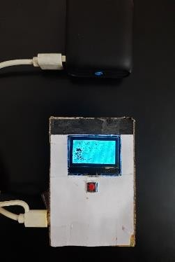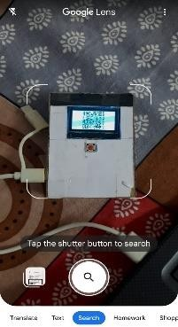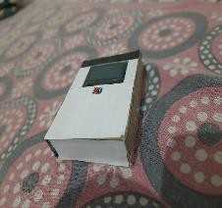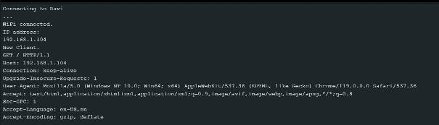

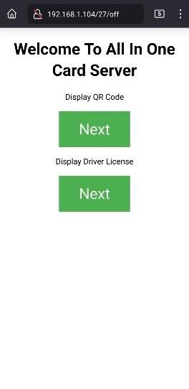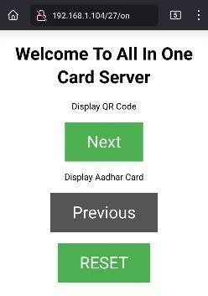

* 1. FUTURE SCOPE

The adaptability of the system allows for future enhancements, such as incorporating additional card types, advanced security features, and integrating with mobile applications for a comprehensive digital wallet experience. The gadget has the potential to pave the way for future advancements in identity verification, safe transactions, and smooth connections with Internet of Things ecosystems that incorporate additional security features like biometric authentication.

* 1. ACKNOWLEDGMENT

The authors are extremely thankful to honorable Director Prof. (Dr.) R. M. Jalnekar, Vishwakarma Institute of Technology (VIT), Pune and Prof. S.M Lambor., Head of Department of Multidisciplinary Engineering (DOME) for their uplifting encouragement and strong moral support. The authors would also like to extend their gratitude towards their project guide Prof. Milind Rane for his valuable directions in successfully completing the project.

* 1. CONCLUSION

In conclusion, the "All-In-One Card" demonstrates promise in revolutionizing the way individuals carry and manage their cards. By integrating multiple cards into a single, portable device, it simplifies everyday transactions and reduces the need for a multitude of physical cards. The project opens up opportunities for further exploration, including enhanced security measures, additional functionalities, and integration with emerging technologies, ultimately contributing to a more efficient and streamlined future in the domain of card-based interactions.

* 1. REFERENCES
  2. Jisha P Reji, Latha Shree S, Maratha Dimple Mohan, Prof. M Rojaramani, “Single ATM Card for multiple access”, 2015
  3. Xiaoling Zhou, “The Application and Research of Intelligent All-in-One Card in the Smart Campus of Colleges and Universities”, 2018
  4. Shanthi Rajaji, Nivetha V, “Multi Bank Smart Card”, 2018
  5. https://wokwi.com/projects/new/esp32
  6. <https://qr.io/dashboard/>
  7. https://javl.github.io/image2cpp/